**Assignment 07**

***Place your query right after each question***

The city’s Crimes Analysis unit has submitted the following data requests. Provide the SQL statements to satisfy these requests. Test the statements and show the query results.

1. Show the average number of crimes reported by an officer.

USE CityJailSummerDB

SELECT AVG(total_num_crimes) AS avg_num_crimes

FROM (SELECT COUNT(*) AS total_num_crimes

FROM crimes c

JOIN crime_officers co

ON c.crime_id = co.crime_id

GROUP BY co.officer_id) AS avg_crime;

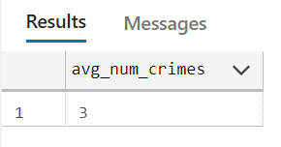

1. Show the total number of crimes by status.

USE CityJailSummerDB

SELECT COUNT([status]) AS AmountOfCrimes, [status]

FROM crimes

GROUP BY [status]

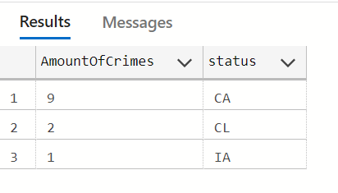

1. List the highest number of crimes committed by a person.

USE CityJailSummerDB

SELECT MAX(CrimesCommited) AS HighestNumOfCrimesCommitedBySomeone

FROM (SELECT criminal_id, COUNT(*) AS CrimesCommited

FROM crimes

GROUP By criminal_id) AS MAX;

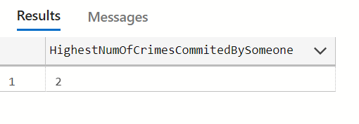

1. Display the lowest fine amount assigned to a crime charge.

USE CityJailSummerDB

SELECT MIN(fine_amount) AS LowestFineAmount

FROM crime_charges

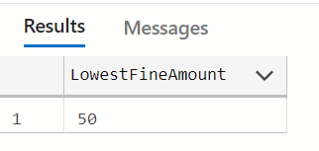

1. List criminals (ID and name) who have multiple sentences assigned.

USE CityJailSummerDB

SELECT criminals.criminal_id, [last], [first]

FROM criminals

JOIN sentences ON criminals.criminal_id = sentences.criminal_id

GROUP BY criminals.criminal_id, [last], [first]

HAVING COUNT(*) > 1

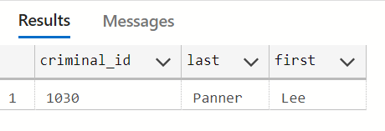

1. List the total number of crime charges successfully defended (guilty status assigned) by precinct. Include only precincts with at least seven guilty charges.

USE CityJailSummerDB

SELECT o.precinct, COUNT(*) AS TotalDefendedCharges

FROM crime_officers co JOIN officers o ON o.officer_id = co.officer_id

JOIN crime_charges cc ON cc.crime_id = co.crime_id

WHERE charge_status = 'GL'

GROUP BY precinct

HAVING COUNT(*) > 7

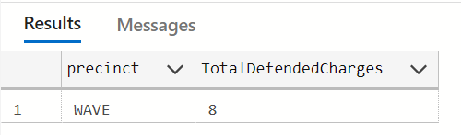

1. List the total amount of collections (fines and fees) and the total amount owed by crime classification.

USE CityJailSummerDB

SELECT  c.classification, (SUM(cc.fine_amount) + SUM(cc.court_fee)) AS TotalAmountOfColections,

(SUM(cc.fine_amount) + SUM(cc.court_fee) - SUM(amount_paid)) AS TotalAmountOwed

FROM crime_charges cc JOIN crimes c ON cc.crime_id = c.crime_id

GROUP BY classification

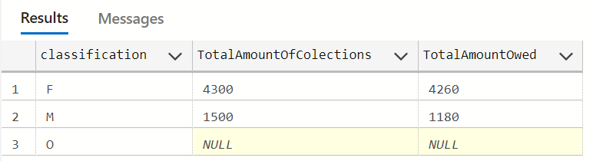

1. List the total number of charges by crime classification and charge status. Include a grand total in the results.

USE CityJailSummerDB

SELECT c.classification,cc.charge_status, COUNT(classification) AS total_num_charges_by_class_and_status

FROM crime_charges cc

JOIN crimes c

ON c.crime_id = cc.crime_id

GROUP BY classification, charge_status

UNION ALL

SELECT 'Grand Total' charge_status, ' ' charge_status, COUNT(*)

FROM crime_charges

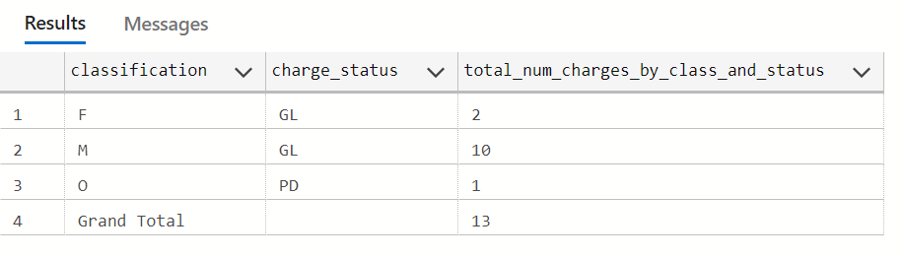

1. Perform the same task as in Question #8 and add a subtotal for each charge status.

USE CityJailSummerDB

SELECT c.classification,cc.charge_status, COUNT(classification) AS total_num_charges_by_class_and_status

FROM crime_charges cc

JOIN crimes c

ON c.crime_id = cc.crime_id

GROUP BY classification, charge_status

UNION ALL

SELECT 'Guilty Charge Status Total' classification, ' ' charge_status, COUNT(charge_status)

FROM crime_charges

WHERE charge_status = 'GL'

UNION ALL

SELECT 'Pending Charge Status Total' classification, ' ' charge_status, COUNT(charge_status)

FROM crime_charges

WHERE charge_status = 'PD';

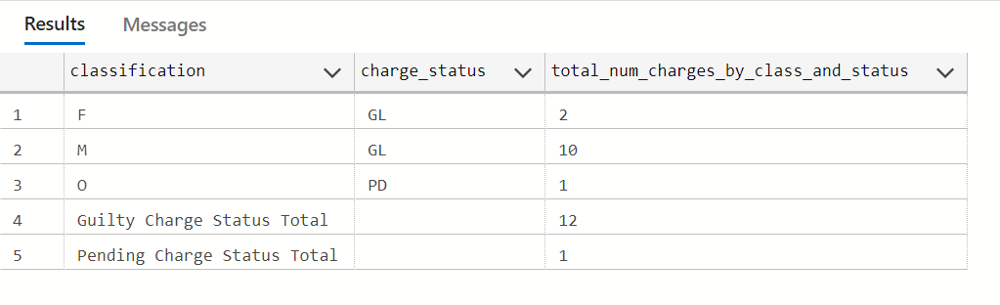

1. Perform the same task as in Question #8 and add a subtotal by each crime classification.

USE CityJailSummerDB

SELECT c.classification,cc.charge_status, COUNT(classification) AS total_num_charges_by_class_and_status

FROM crime_charges cc

JOIN crimes c

ON c.crime_id = cc.crime_id

GROUP BY classification, charge_status

UNION ALL

SELECT 'Felony Classification Total' classification, ' ' charge_status, COUNT(classification)

FROM crimes

WHERE classification = 'F'

UNION ALL

SELECT 'Misdemeanor Classification Total' classification, ' ' charge_status, COUNT(classification)

FROM crimes

WHERE classification = 'M'

UNION ALL

SELECT 'Other Classification Total' classification, ' ' charge_status, COUNT(classification)

FROM crimes

WHERE classification = 'O';

